**POSTMAN OUTPUT SCREENSHOTS**

Login Controller

1.Creating user account

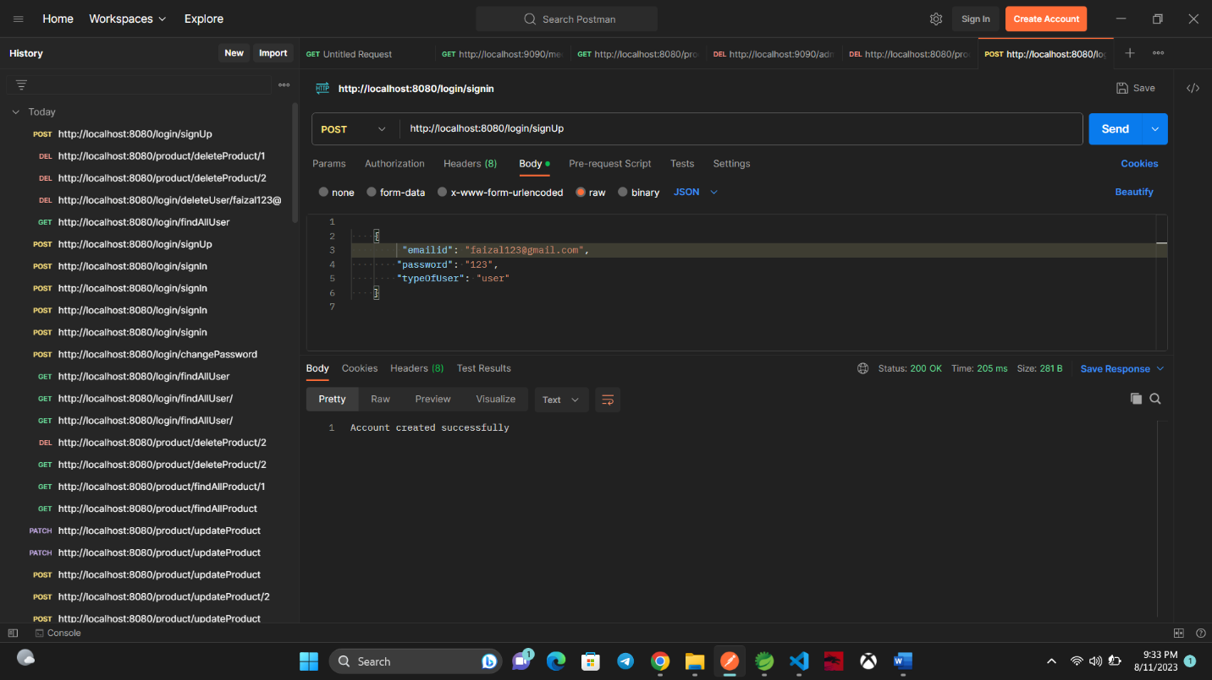

2.Login as user

3.Changing password for user

4.Finding all user

5. Deleting user by Email Id

Product Controller

1.Adding products

2. Finding all products

3. Updating product details

4. Find product by ID

5. Delete Product by ID

